Cybersecurity Analyst Internship
Task Report

[samfelix15@gmail.com]
Task No: [ 24 - Advanced Penetration Test ]

Copyright © 2024 EncryptEdge Labs. All rights reserved
Credit: Offensive Security

Table of Contents
1.0 EncryptEdge Labs Internship Task Report 2
1.1 Introduction 2
1.2 Objective 4
1.3 Requirements 5
2.0 High-Level Summary 9
2.1 Recommendations 9
2.2 Risk exposure over time 10
3.0 Report - Methodologies 11
3.1 Information Gathering 12

4.0 Additionals Item 13
4.1 Screenshots X

1.0 EncryptEdge Labs Internship Task Report

1.1 Introduction
In today's digital age, cybersecurity is a top priority for organizations of all sizes. With the increasing number of cyber threats and attacks, it's essential for organizations to take proactive measures to protect their systems, networks, and applications. One effective way to do this is through penetration testing, also known as pen testing or ethical hacking.
Penetration testing is a simulated cyber-attack against a computer system, network, or web application to assess its security vulnerabilities. The goal of penetration testing is to identify weaknesses and vulnerabilities that could be exploited by malicious actors, allowing organizations to remediate them before they can be attacked.
Penetration testing is a critical component of cybersecurity because it provides a comprehensive assessment of an organization's security posture. By simulating a real-world attack, penetration testing can help organizations identify vulnerabilities that may not be detected through traditional security testing methods.
The importance of penetration testing cannot be overstated. With the increasing sophistication of cyber threats, organizations need to be proactive in identifying and remediating vulnerabilities. Penetration testing provides a proactive approach to cybersecurity, allowing organizations to stay one step ahead of potential attackers.
In this report, we will explore the significance of penetration testing, its importance, and best practices for conducting effective penetration testing. We will also discuss the benefits of penetration testing and provide examples of penetration testing tools and techniques.

1.2 Objective
The objectives of this report are to:
- Explore and understand advanced penetration testing tools and their applications.
- Gain practical experience using these tools in a safe, isolated environment.
- Understand and apply ethical guidelines in the use of advanced testing tools.

With reference to the basics of pent testing, one must lay the following objectives,

1. Provide an Overview of Penetration Testing: This report aims to provide a comprehensive overview of penetration testing, including its benefits, challenges, and best practices
Identify Key Penetration Testing Tools: This report will identify key penetration testing tools, including their features, advantages, and disadvantages.
3. Evaluate the Significance of Penetration Testing: This report will evaluate the significance of penetration testing in identifying and remediating security vulnerabilities.
4. Recommend Best Practices: This report will recommend best practices for conducting penetration testing, including tips for getting started and avoiding common pitfalls.
Penetration testing is a critical component of cybersecurity, enabling organizations to identify and remediate security vulnerabilities before malicious actors can exploit them

1.3 Requirements
The requirements for penetration testing include:
1. Skilled Testers: Penetration testing requires skilled testers who have expertise in security testing and vulnerability assessment.
2. Testing Tools: Penetration testing requires a range of testing tools, including vulnerability scanners, penetration testing frameworks, and exploit tools.
3. Test Environment: Penetration testing requires a test environment that mirrors the production environment, including networks, systems, and applications.
4. Clear Objectives: Penetration testing requires clear objectives, including identifying vulnerabilities, assessing risk, and recommending remediation steps.
Penetration testing requires careful planning, skilled testers, and the right testing tools to ensure effective and efficient testing.
Examples of Penetration Testing Tools
Some examples of penetration testing tools include:
1. Nmap: A network scanning tool used to identify open ports and services on a network.
2. Metasploit: A penetration testing framework used to identify and exploit vulnerabilities in systems and applications.
3. Burp Suite: A web application security testing tool used to identify vulnerabilities in web applications.
4. Wireshark : A network protocol analyzer used to capture and analyze network traffic.

Significance of Penetration Testing
Penetration testing, also known as pen testing or ethical hacking, is a simulated cyber-attack against a computer system, network, or web application to assess its security vulnerabilities. The significance of penetration testing lies in its ability to identify and remediate security vulnerabilities before malicious actors can exploit them.
The importance of penetration testing can be seen in several areas:
1. Identifying Vulnerabilities: Penetration testing helps identify security vulnerabilities in systems, networks, and applications, allowing organizations to remediate them before they can be exploited.
2. Assessing Security Posture: Penetration testing provides a comprehensive assessment of an organization's security posture, identifying areas for improvement and strengthening overall security.
3. Reducing Risk: Penetration testing helps reduce the risk of security breaches by identifying and remediating vulnerabilities, reducing the likelihood of a successful attack.
4. Improving Incident Response: Penetration testing can help improve incident response by identifying potential vulnerabilities and weaknesses, allowing organizations to develop effective response strategies.
5. Enhancing Security Awareness: Penetration testing can enhance security awareness among employees, highlighting the importance of security best practices and the potential consequences of security breaches.
6. Meeting Compliance Requirements: Penetration testing can help organizations meet compliance requirements by identifying vulnerabilities and demonstrating due diligence in maintaining security.

Benefits of Penetration Testing
The benefits of penetration testing include:
1. Improved Security: Penetration testing helps improve security by identifying and remediating vulnerabilities, reducing the risk of security breaches.
2. Reduced Costs: Penetration testing can reduce costs by identifying vulnerabilities and remediating them before they can be exploited, reducing the potential costs of security breaches.
3. Enhanced Reputation: Penetration testing can enhance an organization's reputation by demonstrating a commitment to security and due diligence in maintaining security.
Best Practices for Penetration Testing
To get the most out of penetration testing, organizations should follow best practices, including:
1. Define Clear Objectives: Clearly define the objectives of the penetration test, including identifying vulnerabilities and assessing risk.
2. Use a Structured Methodology: Use a structured methodology for penetration testing, including planning, reconnaissance, exploitation, and reporting.
3. Use Advanced Tools and Techniques: Use advanced tools and techniques, including vulnerability scanners and penetration testing frameworks.
4. Document Findings: Document the findings of the penetration test, including identifying vulnerabilities, assessing risk, and recommending remediation steps.
By following best practices and leveraging penetration testing, organizations can improve their security posture, reduce the risk of security breaches, and protect sensitive data. ‎
2.0 High-Level Summary
Penetration testing is a vital component of cybersecurity, enabling organizations to identify and remediate security vulnerabilities before malicious actors can exploit them. Penetration testing involves simulating a cyber-attack against a computer system, network, or web application to assess its security vulnerabilities.
By simulating a real-world attack, penetration testing provides a comprehensive assessment of an organization's security posture, allowing organizations to stay one step ahead of potential attackers. In this report, we will explore the significance of penetration testing, its importance, and best practices for conducting effective penetration testing.
By leveraging penetration testing tools and techniques, organizations can improve their security posture, reduce the risk of security breaches, and protect sensitive data. As the threat landscape continues to evolve, penetration testing will play an increasingly important role in supporting cybersecurity efforts and protecting against emerging threats.

2.1 Recommendations
Based on the significance of penetration testing, it is recommended that organizations:
1. Conduct Regular Penetration Testing: Conduct regular penetration testing to identify and remediate security vulnerabilities in systems, networks, and applications.
2. Use Advanced Tools and Techniques: Use advanced tools and techniques, including vulnerability scanners and penetration testing frameworks, to identify and exploit vulnerabilities.
3. Prioritize Remediation Efforts: Prioritize remediation efforts based on the risk associated with identified vulnerabilities, focusing on high-risk vulnerabilities first.
4. Continuously Monitor and Test: Continuously monitor and test systems, networks, and applications to identify and remediate vulnerabilities, ensuring the security posture of the organization.
5. Train and Educate Employees: Train and educate employees on security best practices and the importance of penetration testing, ensuring that they understand the role they play in maintaining security.
6. Use Penetration Testing to Meet Compliance Requirements: Use penetration testing to meet compliance requirements, demonstrating due diligence in maintaining security and reducing the risk of non-compliance.
By following these recommendations, organizations can ensure that their penetration testing initiatives are effective and efficient in identifying and remediating security vulnerabilities.

2.2 Risk Exposure over Time
The risk exposure over time for organizations that do not conduct penetration testing can be significant. Without penetration testing, organizations may be more vulnerable to security breaches, as they may not identify and remediate vulnerabilities in a timely manner. This can lead to:
1. Increased Risk of Security Breaches: Without penetration testing, organizations may be more vulnerable to security breaches, as they may not identify and remediate vulnerabilities.
2. Increased Costs: Without penetration testing, organizations may incur higher costs, as they may need to respond to security incidents and remediate vulnerabilities.
3. Reduced Trust: Without penetration testing, organizations may experience reduced trust from customers, partners, and stakeholders, as they may be perceived as not taking adequate measures to protect sensitive data.
By conducting penetration testing, organizations can identify and remediate vulnerabilities, reducing the risk of security breaches and protecting sensitive data.

3.0 Methodologies
The methodology for penetration testing includes:
1. Planning and Preparation: This phase involves defining the scope of the test, identifying the testing team, and establishing clear objectives.
2. Reconnaissance: This phase involves gathering information about the target system, network, or application, including identifying potential vulnerabilities.
3. Exploitation: This phase involves exploiting identified vulnerabilities to gain unauthorized access to the target system, network, or application.
4. Reporting: This phase involves documenting the findings of the penetration test, including identifying vulnerabilities, assessing risk, and recommending remediation steps.
By following a structured methodology, organizations can ensure that their penetration testing initiatives are effective and efficient.

3.1 Information Gathering
Information gathering is a critical phase of penetration testing, enabling testers to gather information about the target system, network, or application. Key sources of information include:
1. Publicly Available Information: This includes information available on the internet, such as company websites, social media, and public records.
2. Network Scans: This includes scanning the target network to identify open ports, services, and potential vulnerabilities.
3. System Enumeration: This includes gathering information about the target system, including user accounts, groups, and system configuration.
By gathering information about the target system, network, or application, testers can identify potential vulnerabilities and develop effective testing strategies.
With reference to my report information was gathered based on intensive research and resources provided to me by EncryptEdgeLabs.

GitHub Repositories:
- Metasploit Scripts and Modules
- Awesome Burp Suite

Articles:
- Metasploit Unleashed: A Beginner’s Guide
- Introduction to Burp Suite for Web Security

4.0 Additional Items
Under this section, I will include completed screenshots of mandatory lab assignments given to me. This land is to help develop skills and good hands on training and gaining fundermental and advanced knowledge in all fields and area of cybersecurity.
Screenshots will include Tryhackme lab rooms of Metasploit introduction, Burpe Suite Repeater, and Empire.

Lab Challenges
I encountered little challenges in my Burpe Suite: Repeater lab
Lost connection to server running the attackbox and was unsble to complete 3 task.
Thank you

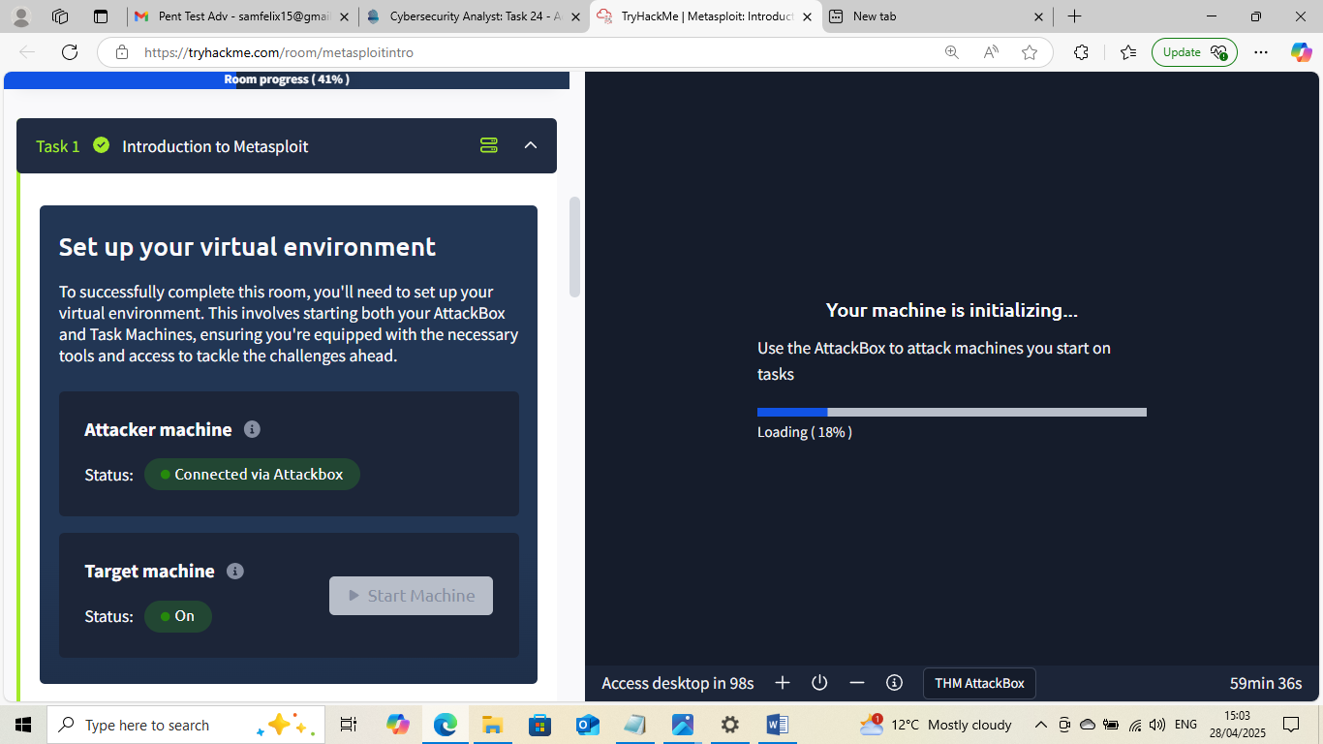

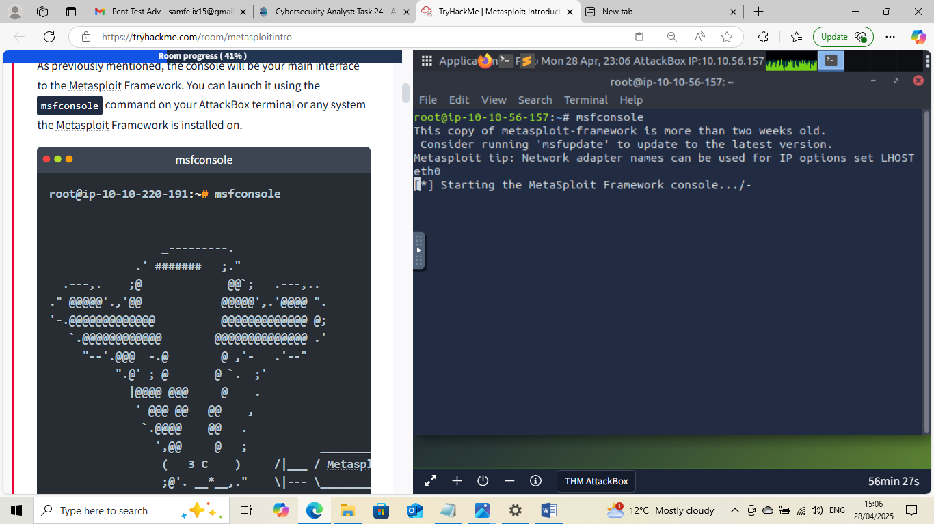

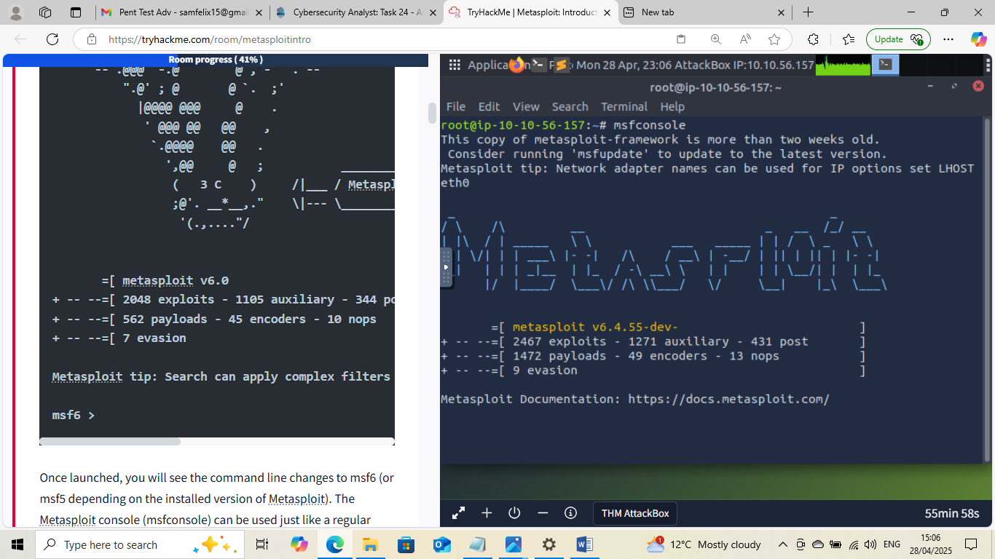

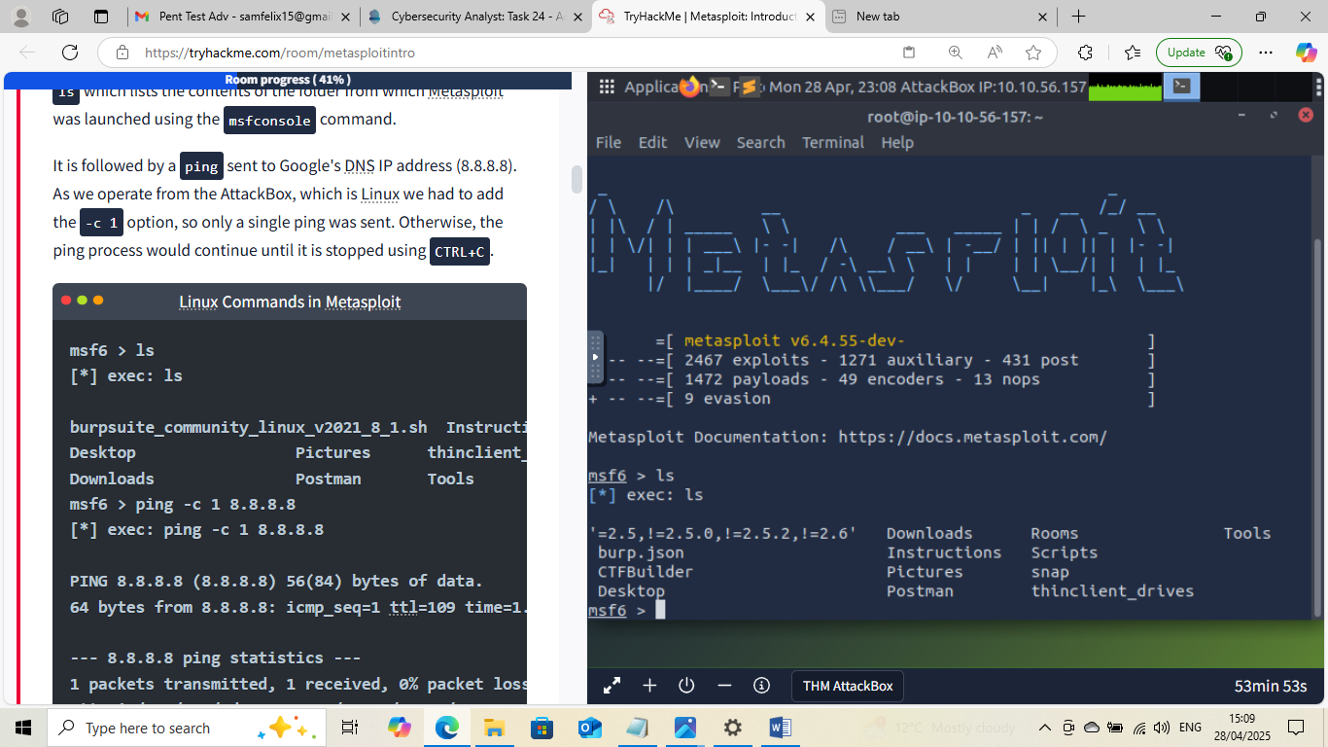

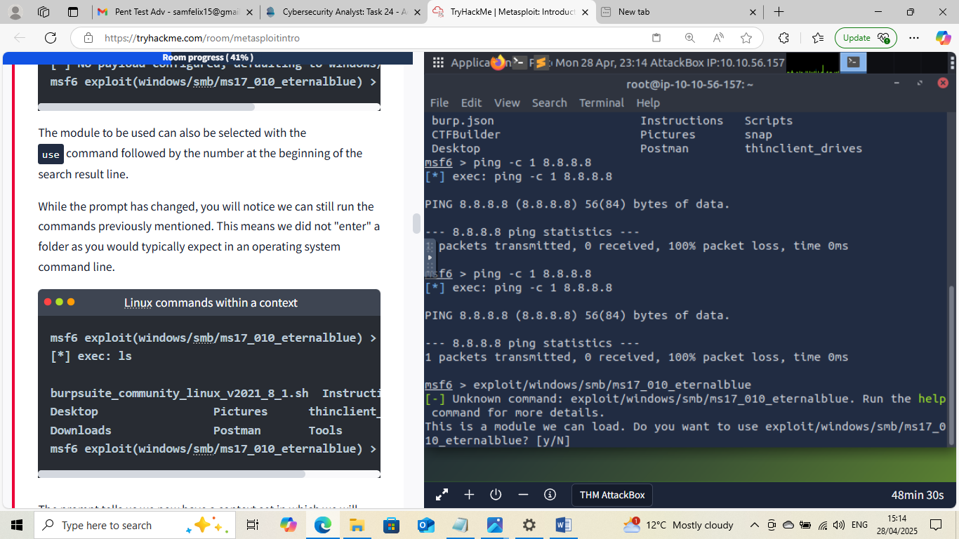

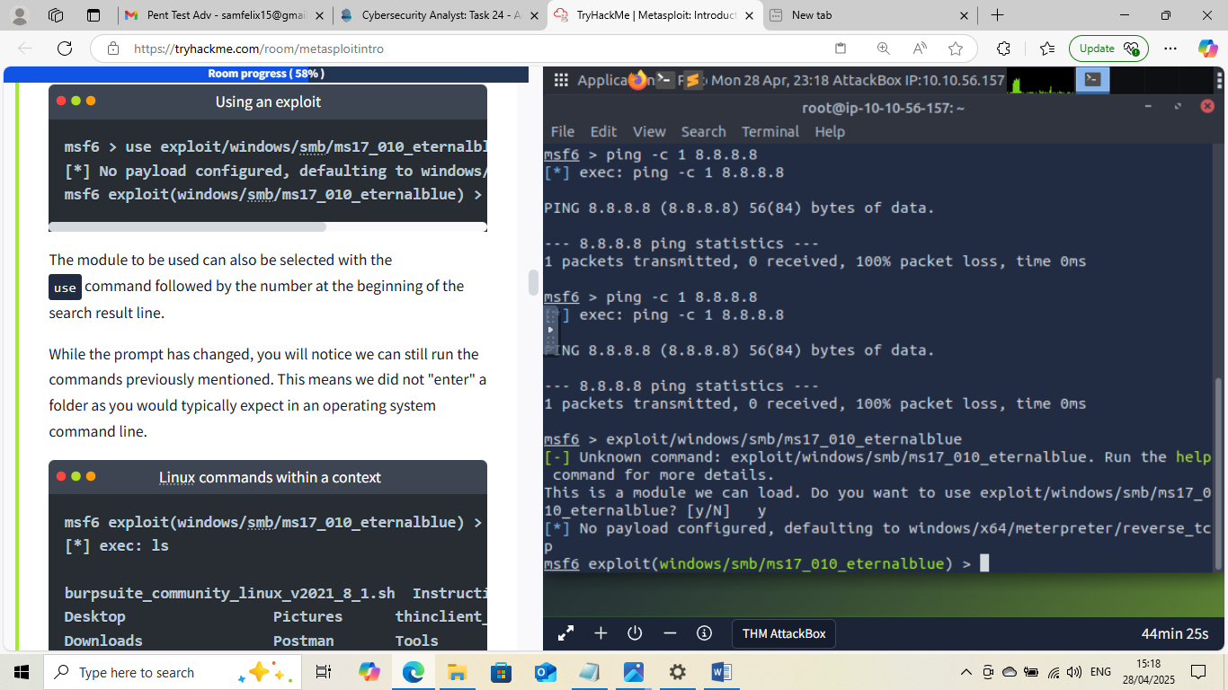

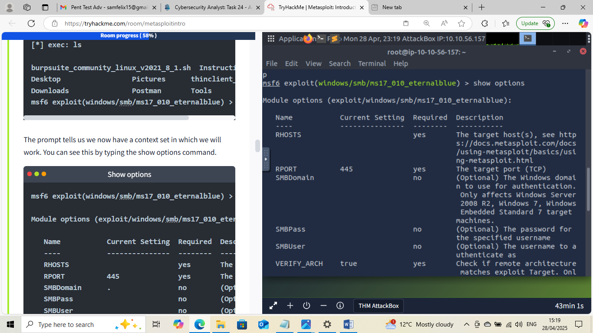

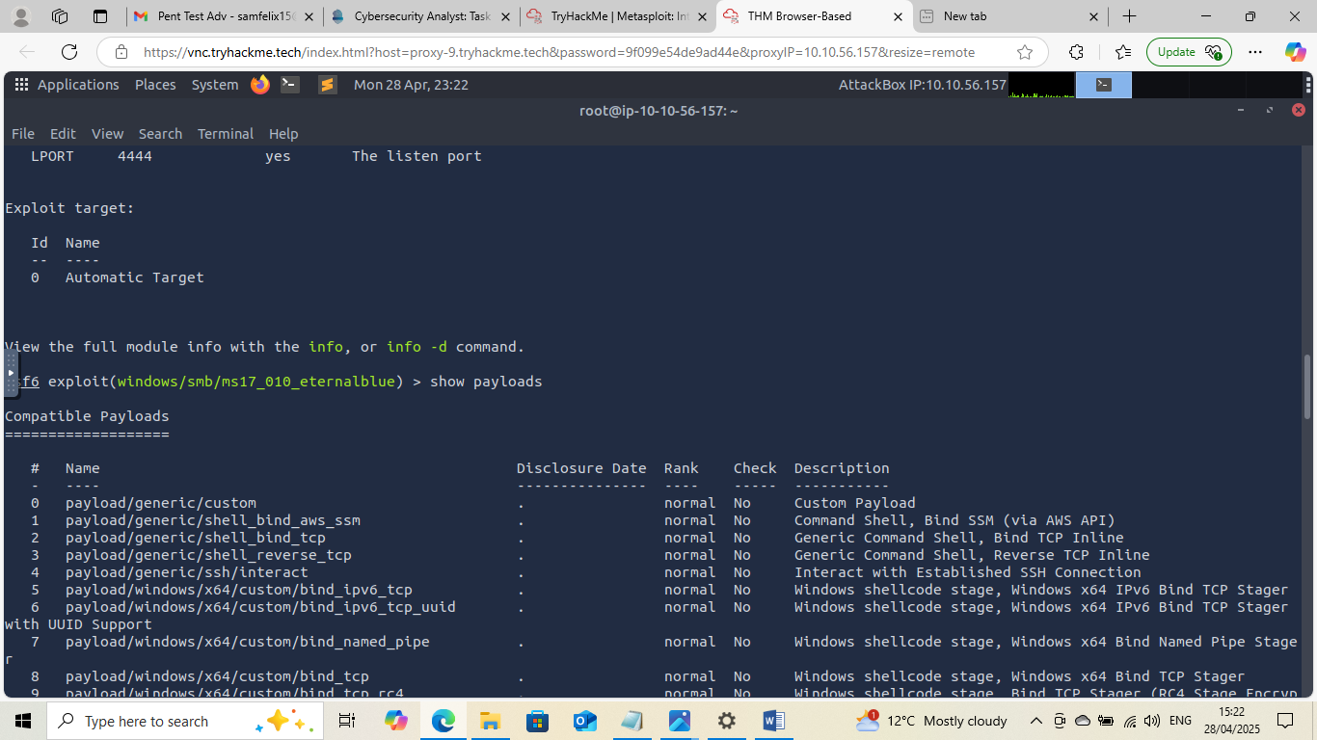

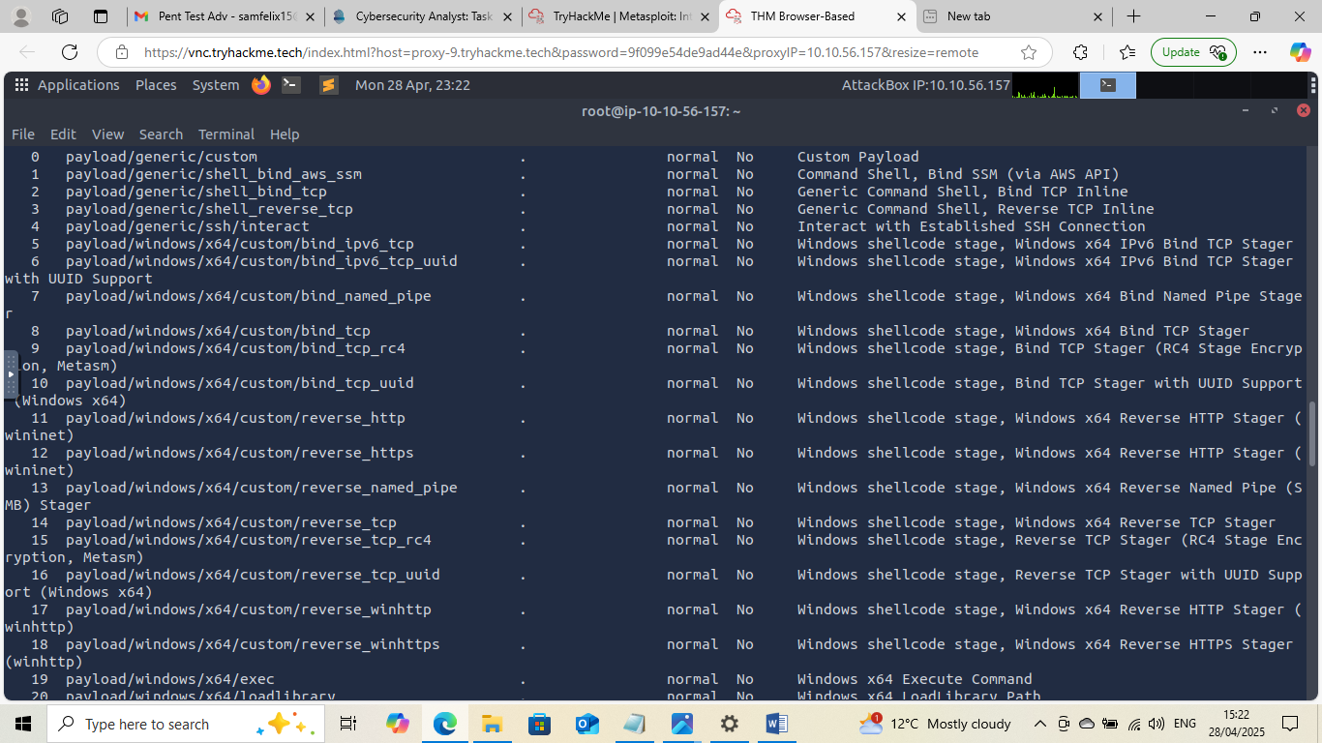

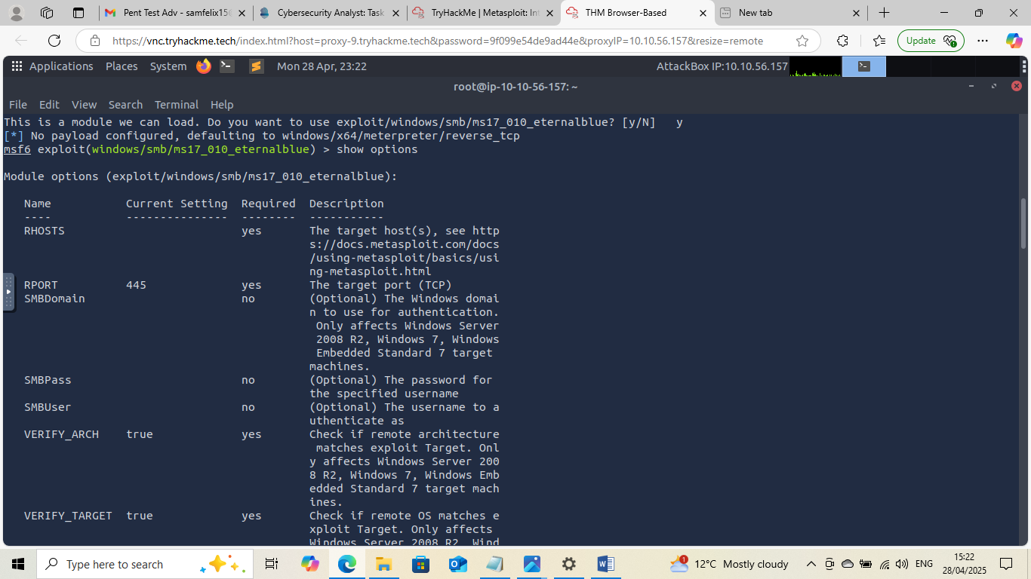

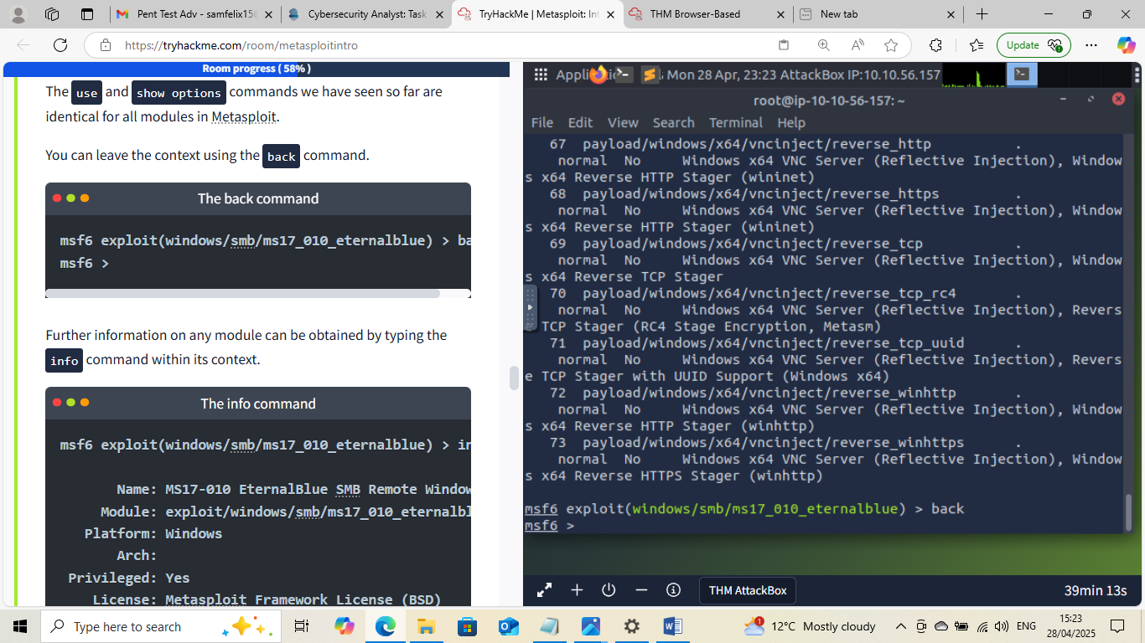

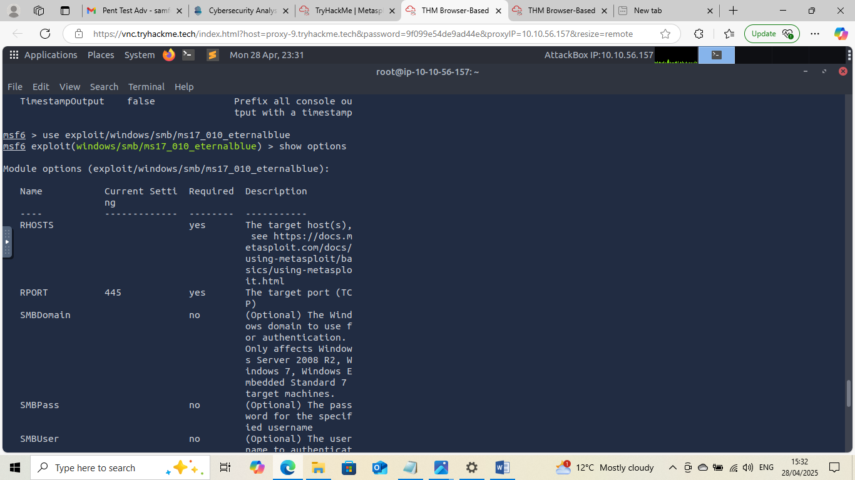

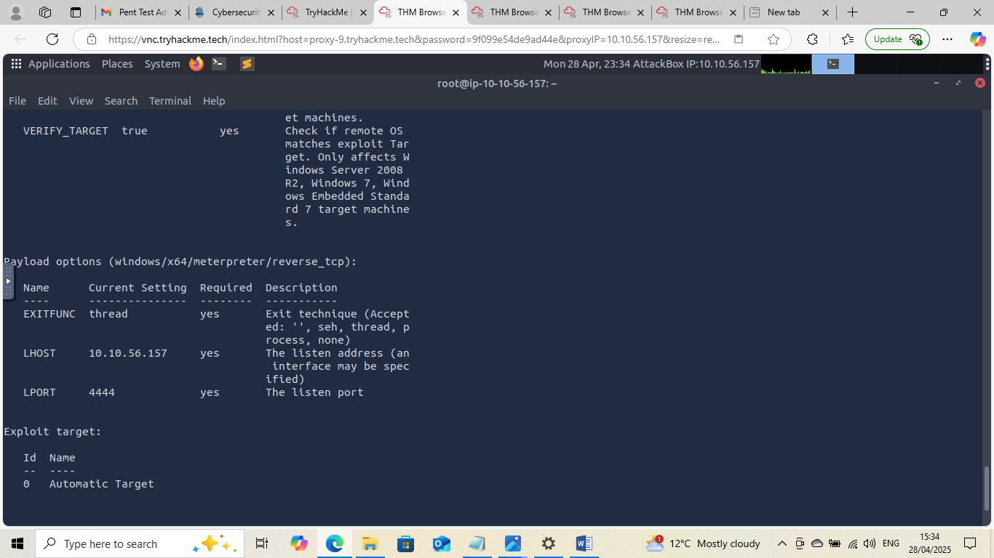

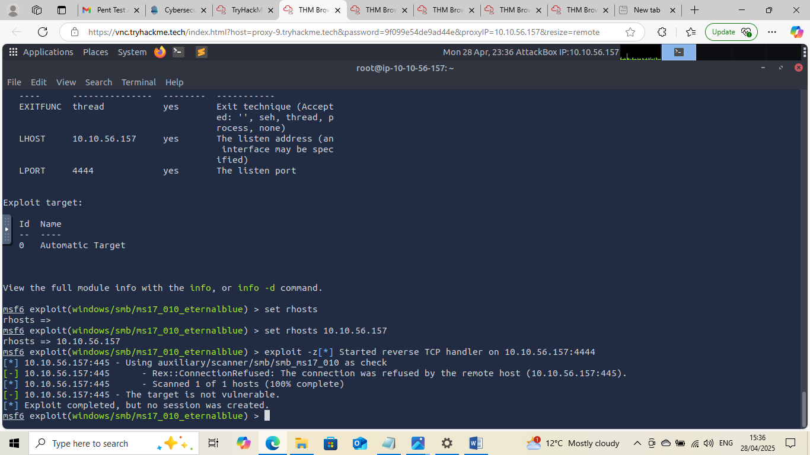

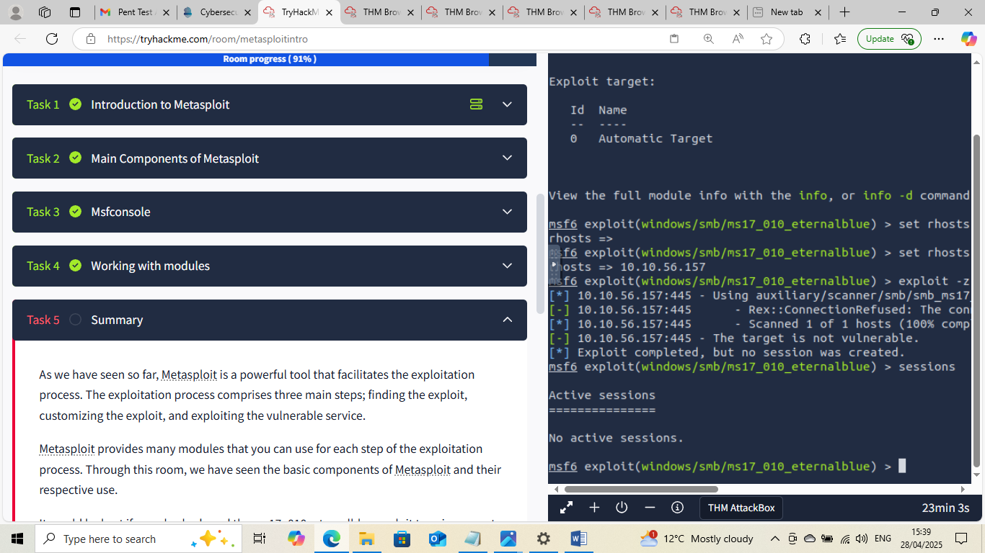



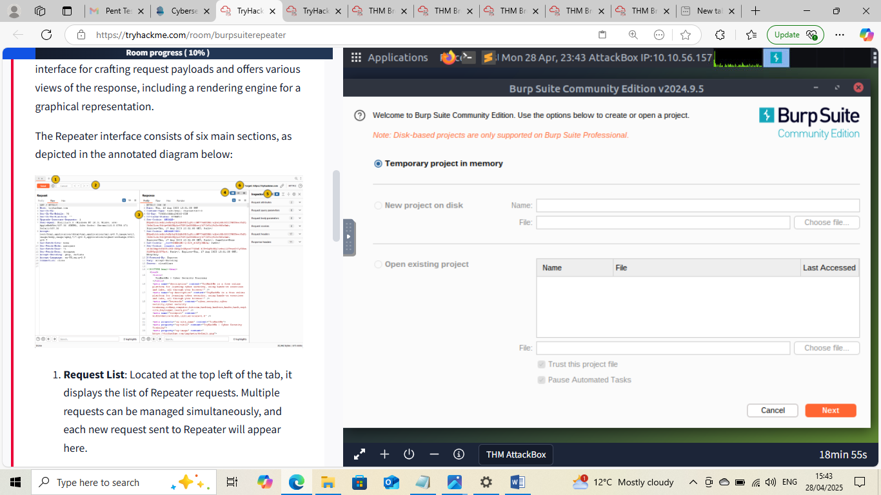


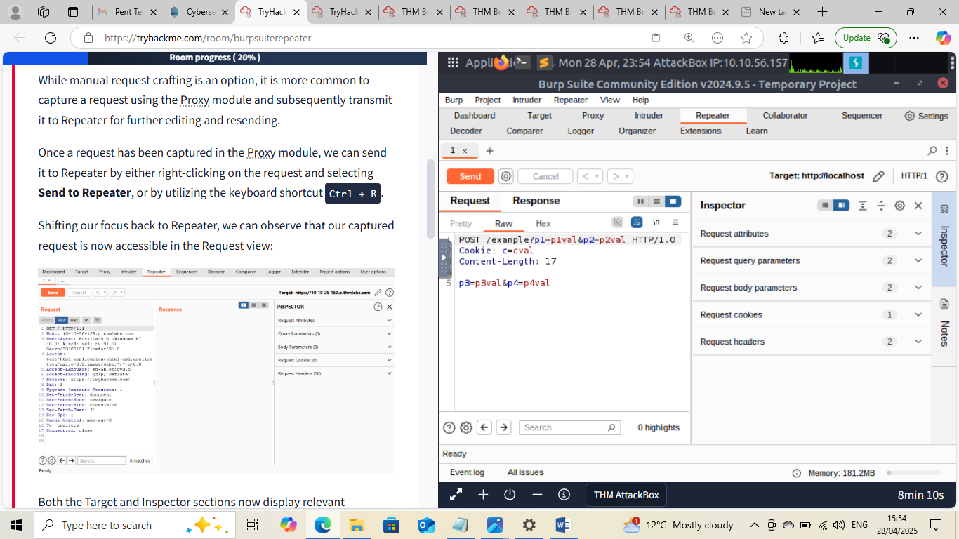

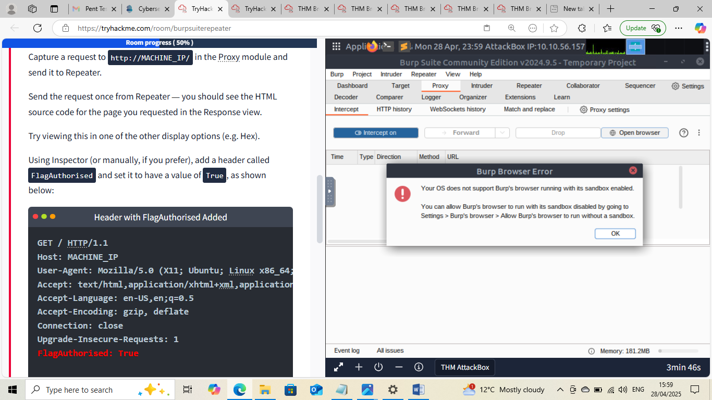






This Internship Task report was developed on [April, 29, 2025]

By:
[ samfelix15@gmail.com ]

